**WRITING QUESTIONS**

1. **Write questions about Michael and his family for the answers.**

My name’s Michael. I live in Vancouver, British Columbia, in Canada. Winter in Vancouver is cold. It’s rainy, and snowy, too. Winter is my favorite season. I like winter sports. I go to Whistler, a ski resort, every weekend. It’s in the mountains, and I go skiing there. My brother also lives in Vancouver, but my parents live on Victoria Island. Yesterday, my parents saw my brother at his house. They brought two ski jackets for us. One is red and one is gray. I want the gray one.

1. ______________________________________________________________________________?

Every weekend.

1. ______________________________________________________________________________?

His brother.

1. ______________________________________________________________________________?

The gray one.

***PART A - KEY:***

***1. How often does Michael / he go to Whistler / to the mountains / skiing / a (ski) resort***

***2. Who did Michael’s / his parents see (at his house / yesterday)***

***3. Which (ski) jacket does Michael / he want***

1. **Write questions about the underlined words.**

1. ______________________________________________________________________?

Ashley went to the library.

2. ______________________________________________________________________?

No, she isn’t going to graduate in May.

3. ______________________________________________________________________?

We need two bottles of milk.

4. ______________________________________________________________________?

I’d like to eat pizza.

***PART B - KEY:***

***1. Where did Ashley go?***

***2. Is she going to graduate in May?***

***3. How much milk do we / you need?***

***4. What would you like to eat? Would you like to eat pizza or pasta / hamburger etc.?***

**WRITING SECTION**

**A. Complete the second sentence so that it means the same as the first.**

1. Jane’s hair is brown.

Jane has _______________________________________________.

2. Sam goes to school on foot because lives very close to the school.

Sam __________________________________, so he __________________________________.

3. The apartment has a large kitchen and three bedrooms.

There _______________________________________________________ in the apartment.

4. Kevin does very well on his exams. He studies very hard.

Kevin ________________________________ because he _________________________________.

5. Jennifer Lawrence is an actor. She is very beautiful.

Jennifer Lawrence is ________________________________ actor.

***PART A - KEY:***

***1. brown hair***

***2. lives (very) close to (the) school … goes to school on foot***

***3. is a large kitchen and three bedrooms***

***4. does (very) well on his exams … studies (very) hard***

***5. a (very) beautiful***

**B. Write 8-10 sentences about YOUR ACTIVITIES LAST FRIDAY. Use at least TWO of the linkers from the box and at least FOUR TIME EXPRESSIONS. Use POSITIVE and NEGATIVE sentences.**

|  |  |  |  |  |
| --- | --- | --- | --- | --- |
| **and** | **but** | **or** | **because** | **so** |

* ***You can write this on Google Doc and send it to me if you want.***

**VOCABULARY SECTION**

1. **Read about Paula and Jake’s holiday in México. Fill each gap in the text with a word from the box. Use each word only ONCE. Be careful, there is ONE EXTRA WORD.**

|  |  |  |  |  |  |
| --- | --- | --- | --- | --- | --- |
| flew | returned | cloudy | climbed | visited | weather |
| decided | sunrise | wonderful | accident | bought |  |

My name is Paula and my husband’s name is Jake. We live in Denver, Colorado, in the US. We usually have our summer holiday in the US, too, but last summer we (1) ____________________ to go to México for our holiday. We (2) ____________________to México City from Denver. México City is a great place. It has (3) ____________________ restaurants with good food. On our first day in México City, the (4) ____________________ was hot and sunny. We took the subway to Chapultepec Park and (5) ____________________ the castle there. The park and the castle were beautiful. The next day we got up very early and went to the top of Iztaccíhuatl Mountain. We looked at the beautiful scenery and watched the sunrise. Then, we drove back to México City and (6) ____________________ to our hotel. After we had a rest, we went for a walk in the old city and (7) ____________________ some gifts for our friends. On our last day in México City, it was (8) ____________________. We didn’t see the sun that day, but we saw the Pyramid of the Sun! We got up late, had a big breakfast and then took the bus to the pyramid. We (9) ____________________ the stairs to the top – 248 steps! I had a small (10) ____________________ on the pyramid. I fell down and hurt my hand, but now I feel better. Jake and I loved México City. We want to go next year, too!

***PART A - KEY:***

***1. decided 2. flew 3. wonderful 4. weather 5. visited***

***6. returned 7. bought 8. cloudy 9. climbed 10. accident***

1. **Read the following text, and fill in each blank with a word from the box. There are more words than you need. Do not change the forms of the words. Use each word only ONCE.**

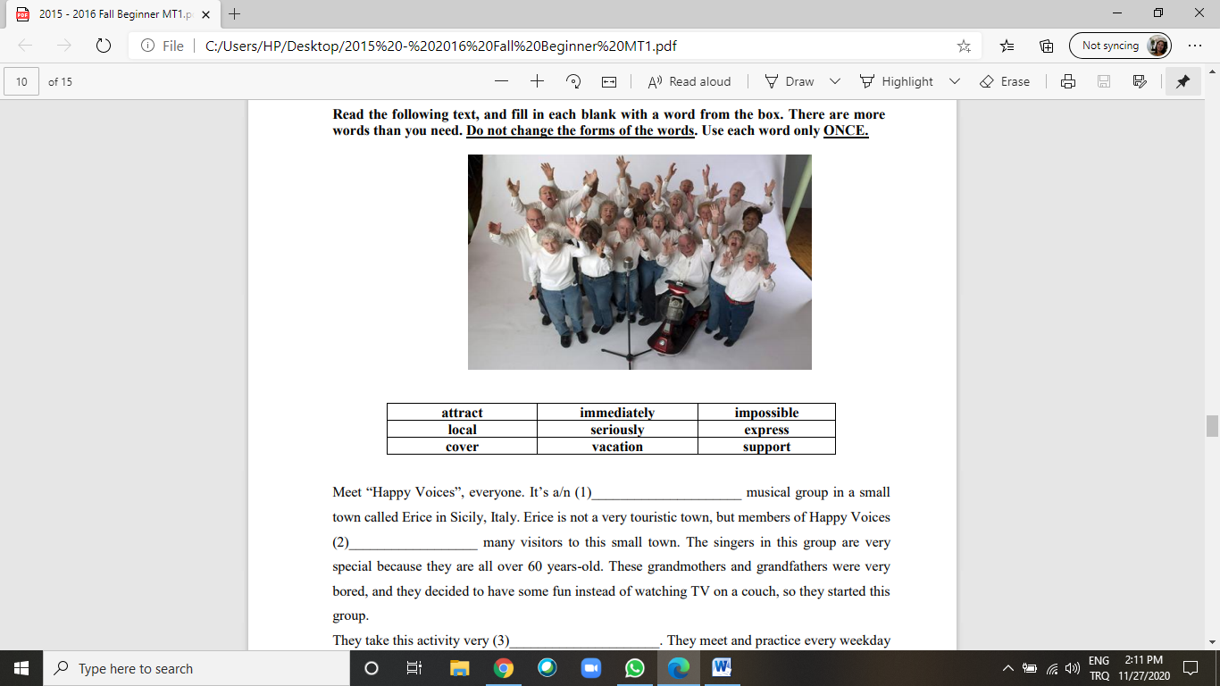

Meet “Happy Voices”, everyone. It’s a/n (1) _____________________ musical group in a small town called Erice in Sicily, Italy. Erice is not a very touristic town, but members of Happy Voices (2) __________________ many visitors to this small town. The singers in this group are very special because they are all over 60 years-old. These grandmothers and grandfathers were very bored, and they decided to have some fun instead of watching TV on a couch, so they started this group. They take this activity very (3) _____________________. They meet and practice every weekday and prepare monthly concerts. They sing pop, jazz, and folk songs. Their children and grandchildren come and watch these concerts, so their concerts are very emotional. They love being part of this group because it gives them energy. Some of them can’t walk without (4) _____________________, some of them have psychological problems and some suffer from serious illnesses, but when they sing, they forget about everything. They (5) ____________________ their feelings in songs, and this relaxes them.

***PART B - KEY***

***1. local 2. attract 3. seriously 4. support 5. express***